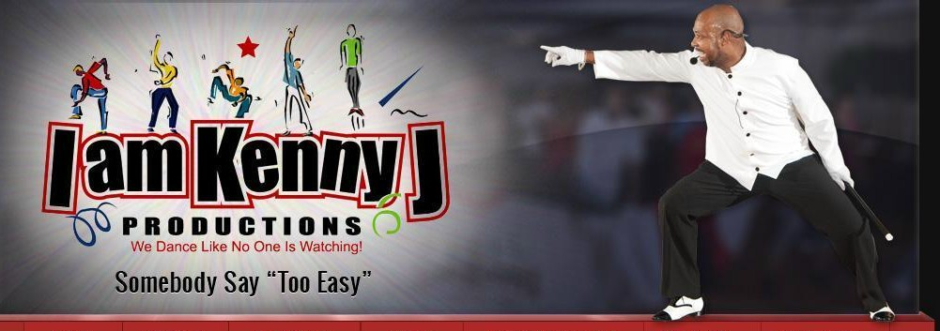
The Claridge Hotel
123 South Indiana Ave
Atlantic City, NJ 08401
$119 + tax & resort fee per night
Reservation Code: KENNYJ
Website: http://claridge.com/
Phone: 1-844-224-7386
I am Kenny J Productions
PO Box 730
Maple Shade NJ 08052
Telephone: 609-733-3621
Email: iakjp@iamkennyj.com
Web: www.iamkennyj.com

I AM KENNY J PRODUCTIONS
WEEKEND EXTRAVAGANZA,
SOUL LINE DANCE SYMPOSIUM AND
SCHOLARSHIP AWARDS CEREMONY

November 1-3, 2019

Registration Form
Please Print
First Name: |  |  |  |  | Last Name:
Email Address:
Address:
City, State, Zip:
Cell Phone: |  | Line Dance Name:
T-Shirt Size:  (circle size) | S M L XL 2X 3X 4X |  |  |  |  |  |  |  |  | M | L | XL | 2X | 3X | 4X
 | LINE DANCE GROUP AFFILIATION INFORMATION
Dance Group Name:
City: |  |  |  |  |  | ST:
Favorite Dance:
One Plan - One Fee: Platinum Package  Includes: Entire Weekend Itinerary, T-Shirt & Souvenir Journal |  |  |  |  |  |  |  |  | $150.00

Make checks payable to: I am Kenny J Productions
Credit Card Payment available online at www.iamkennyj.com ($5 fee)

Return completed form with check or money order payment to:
IAKJP (payable)
PO Box 730, Maple Shade, NJ 08052

NO REFUNDS / REPLACEMENTS ONLY

I agree, and acknowledge, that neither I am Kenny J Productions Social Club, nor any of its members, may be held liable for any damage, theft or injury that may result to myself or my property during my attendance at this event. I further acknowledge that this event will be recorded via photo and video, and those pictures and videos are royalty-free and the property of IAKJP.

Signature:

IAKJP Admin Only
Date Rec’d |  | Total Amount |  | Rec’d by: | Seating:
Cash | Check # |  | Credit Card Type(Online): |  |  | T-Shirt

