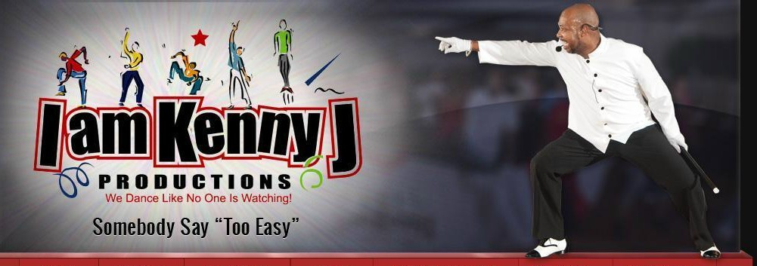

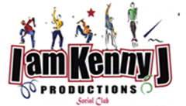
I am Kenny J Productions
Souvenir Journal
Information committee
Telephone: 609-800-4272
Email: iakjp@iamkennyj.com
Web: www.iamkennyj.com
The Claridge Hotel
123 South Indiana Ave
Atlantic City, NJ 08401
$119 + tax & resort fee per night
Reservation Code: KENNYJ
Website: http://claridge.com/
Phone: 1-844-224-7386

I AM KENNY J PRODUCTIONS
WEEKEND EXTRAVAGANZA,
SOUL LINE DANCE SYMPOSIUM AND
SCHOLARSHIP AWARDS CEREMONY

November 1-3, 2019

Souvenir Journal Application
Name:
Business Name:
Address:
City, State, Zip:
Phone: | Email:
AD SIZE |  | PRICE
Outside Back Cover SOLD SOLD SOLD SOLD SOLD SOLD SOLD |  | $250.00
Inside Front Cover |  | $200.00
Inside Back Cover |  | $200.00
Full Page |  | $150.00
Half Page |  | $ 85.00
Quarter Page |  | $ 45.00
Business Card |  | $ 25.00
Patron (name) |  | $ 5.00
TOTAL

Support the IAKJP, Herman and Connie English Memorial Scholarship Fund by advertising your business or organization at the I am Kenny J Productions Weekend Extravaganza, Soul Line Dance Symposium and Scholarship Awards Ceremony. Your ad will be featured in our souvenir journal and shared amongst the many participants in attendance. Attach your business card and/or a separate sheet for your ad. All artwork submitted must be camera ready or submitted in .gif or .jpg format. Please submit only one ad per form.

Return completed form with payment to: | IAKJP Admin Only
IAKJP (payable) | Amount Received: $
Souvenir Journal | Cash Check# MO#
P.O. Box 730 | Date Received:
Maple Shade, NJ 08052 | Signature:
Deadline: September 30, 2019 | Deposited:

