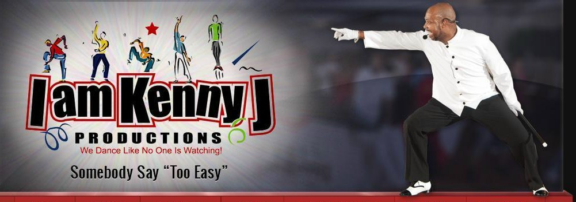
The Claridge Hotel
123 South Indiana Ave
Atlantic City, NJ 08401
$119 + tax & resort fee per night
Reservation Code: KENNYJ
Website: http://claridge.com/
Phone: 1-844-224-7386
I am Kenny J Productions
PO Box 730
Maple Shade NJ 08052
Telephone: 609-733-3621
Email: iakjp@iamkennyj.com
Web: www.iamkennyj.com

I AM KENNY J PRODUCTIONS
WEEKEND EXTRAVAGANZA,
SOUL LINE DANCE SYMPOSIUM AND
SCHOLARSHIP AWARDS CEREMONY

November 1-3, 2019

Vendor Registration Form
Please Print
Business Name:
Attendee Name:
Address:
City, State, Zip:
Phone: |  | Email:
Selling Merchandise:
Additional Attendee Name:
T-Shirt Size: (if applicable) | S |  | M | L | XL | 2X | 3X | 4X
Registration Packages:
Platinum: Vendor Plus Package  Includes: 3 Day Vendor fee and 2 event registrations |  |  |  |  |  |  |  |  | $400.00
Gold: Vendor Package  Includes: 3 Day Vendor fee and 1 event registration |  |  |  |  |  |  |  |  | $250.00
Silver: Vendor (Saturday) Day Package  Includes: Saturday Vendor fee only |  |  |  |  |  |  |  |  | $100.00
Bronze: Vendor (Friday or Sunday) Day Package  Includes: Friday or Sunday Vendor fee only |  |  |  |  |  |  |  |  | $75.00
Additional Table Fee |  |  |  |  |  |  |  |  | $75.00
Additional T-Shirt size (Platinum package only) S M L XL 2X 3X 4X
Total

Make checks payable to: I Am Kenny J Productions
Credit Card Payment ($5 processing fee) available online at www.iamkennyj.com

ALL VENDOR FEES MUST BE PAID IN FULL PRIOR TO SET UP
Due to limited space, we are only able to accommodate outside fixtures (clothes racks, etc.) on a case by case, first come/first serve basis. If you are approved, you would be allowed to use one (1) fixture in addition to the table we provide (pre-approval required). However, if you are in need of additional space, you have the option of purchasing an additional table for a flat fee of $75.

Signature:

IAKJP Admin only
Date Rec’d: | Total Amount: | Rec’d by: | Payment Type:

